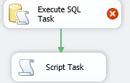

1. Create a String variable to assign the result to (**User::XMLContent type string )**



2. Add Execute SQL task to Control Flow

2.1. Set Result Set property to **XML**  
2.2. Set **connection properties**

2.3 Enter a **SQL statement** which uses FOR XML to return an XML stream

The sql must include FOR XML AUTO

SELECT * from instance WITH(NOLOCK)

FOR XML AUTO

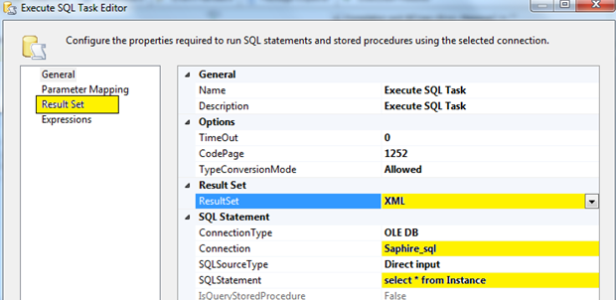

2.4. Click on **Result Set** on the left hand list (under Parameter Mapping)  
2.5. Set the **Result Name** to be 0 (zero)

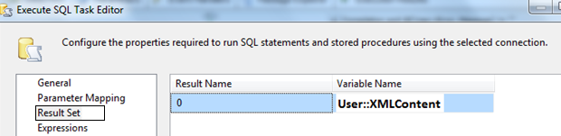

3. Add a Script task and write out the contents of the variable to a file as follows

Set input variable

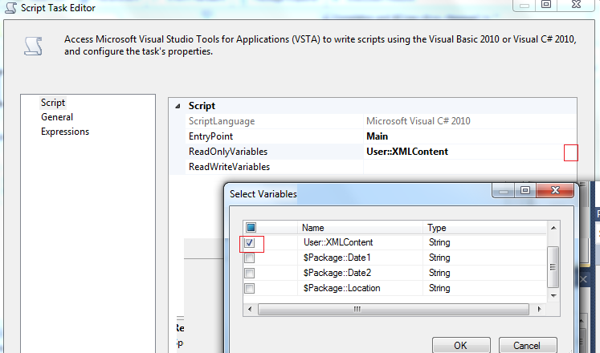

public void Main()

{

System.IO.File.Delete(@"C:\test.xml");

System.IO.StreamWriter sw = new System.IO.StreamWriter("C:\\test.xml");

sw.Write(Dts.Variables["User::XMLContent"].Value.ToString());

sw.Dispose();

Dts.TaskResult = (int)ScriptResults.Success;

}

Public Sub Main()

Dim sw As New IO.StreamWriter("C:\Temp\test.xml")  
sw.Write(Dts.Variables("User::XMLContent").Value.ToString())  
sw.Dispose()

Dts.TaskResult = Dts.Results.Success

End Sub